**Title: Centered and typed in 14-point Century font in bold**

Presenter’s name

**Name of Affiliation**

**1. English as an Asian Language**

The concept of English as an Asian language is based on the fact that English is here to stay as an indispensable language for intranational communication and/or international communication in many countries of the region. In Southeast Asia, for example, English is used as an indisputable lingua franca for regional cooperation in the ASEAN (Association of Southeast Asian Nations) organization comprising ten states.

All other countries recognize the extraordinary importance of English as a language of wider communication in Asia and of course the world around, and put a redoubled emphasis on English language teaching (ELT). China, a country of 1.2 billion people, has 300 million students enrolled in the English classrooms. Japan has initiated a full-fledged action program to pave the way for improved ELT in five years, with a focus on teaching English in English in primary and secondary schools.

The use of English as an Asian language encourages the teaching and learning of English in Asian contexts. As such, the SEAMEO RELC (Southeast Asian Education Ministers' Organization’s Regional Language Centre) stationed in Singapore hosts a large number of teachers and students from other Asian countries for teacher training and language instruction. Likewise, Philippine universities attract Asian students for ELT programs. The U.S.A. and the U.K. used to be the places for ambitious students to go to in order to learn English. But now this urge has comparatively weakened. Some Asian countries are added to a list of their destinations.

**2. Two Characteristics of Contemporary English**

In view of the tendency, it is imperative that we explore various intranational and international issues involved in recognizing and promoting English as an Asian language and teaching, learning, plus using English as such. Actually, however, it is extremely difficult to comprehend a whole range of logical deductions stemming from the idea of English as an Asian language. In this presentation, I would like to address one ramification; that is, the multiculturalization of English in Asia.

Contemporary English has two major characteristics: internationalization and diversification. The internationalization of English entails the diversification of English. People often find it difficult to understand the diversification part, but the diversification is the price you have to pay for the internationalization.

**3. Diffusion and Adaptation**

This phenomenon can be grasped in terms of the relation between diffusion and adaptation.



When American English or British English is transplanted to foreign countries, the language goes through an adaptive process of enculturation and indigenization to get learned and used by local people there. It is likely that these processes result in the development of regional and indigenized varieties of English that new users identify themselves with and find it easier to handle.

**4. Nonnative Speakers' Contribution to the Expansion of English as a Multicultural Language**

As the spread of English progresses, English is bound to reflect a diversity of disparate cultures. Every language has an indefinite capacity of structural and functional modulation and expansion. There is no language that has used up its inherent potentiality. The portion that the native speakers have explored is very limited. There is still a lot to be exploited by the nonnative speakers. Once a language is transferred to nonnative speakers, they start exploring certain aspects of the language that have not been touched by the native speakers. The nonnative speakers explore those areas based on their own linguistic and cultural experiences.

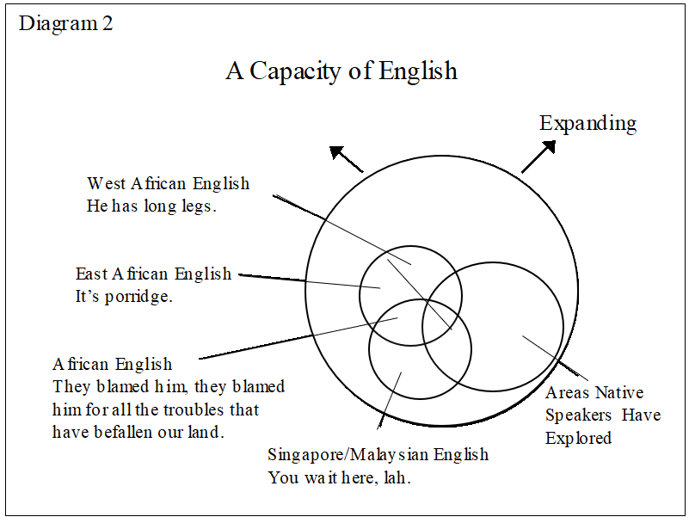

Let me illustrate this very briefly. For instance, Singapore and Malaysian English, although sharing much with native speaker English, introduces the use of tens of different sentence-final particles, like "Wait here, la." The rationale for these expletives is that they express a wide range of delicate shades of meaning; in other words, the ethos of the speakers. Japanese speakers of English might add some of theirs, such as "I like sushi-ne."

African speakers also enrich the language with an array of syntactic and lexical creations. While African English shares a lot with native speaker English, it also shows a considerable amount of similarities to other nonnative speaker varieties, for example, to Singapore and Malaysian English in its use of syntactic reduplication. "They blamed him, they blamed him" here means "they blamed him" repeatedly and harshly. In African English, as in Singapore and Malaysian English, reduplication functions as a means of adverbial sophistication.

The West African expression here is representative of many metaphorical innovations New Englishes can contribute to English. "To have long legs" means "to know many people" based on the metaphorical reference of "having long legs" to "walking around far and widely." As native speakers have produced hundreds of body-part metaphors (such as "a bitter tongue," "a sweet tooth," and "green fingers," so have nonnative speakers on the basis of their cognitive experience .

The students' reactions were a remarkable departure from the traditional understanding that nonnative speakers should conform to native speakers' communication styles by all means, the seismic change in attitude that was made possible by recognizing English as a multinational and multicultural language.

Actually, Asian speakers of English would not have difficulty handling a similar situation. We could infer the interlocutor's request and might even volunteer the solution. Very often, Asian speakers of English deviate from American or British norms of communication and thereby understand each other. We may communicate with each other better when we do not follow the native speakers' norms than when we do.

**5. For Further Commitment**

If we establish English as an Asian language, it becomes appropriate that Japanese and other Asian nationals take responsibility for the language which many of us are learning as well as enriching as a means of wider communication. To make it happen, we have to share our research and policy proposals with a wide range of people here and abroad. We have to cooperate with a variety of professional communities. In view of this, I strongly urge that the Japanese Association for Asian Englishes be further committed to these innovative action programs with scholarship and leadership.

## Bibliography

Funahashi, Yoichi. 2000. *Aete eigo kouyougo ron*. Tokyo:Bunshun Shinsho.

Honna, Nobuyuki and Yuko Takeshita. 1998. “On Japan’s Propensity for Native Speaker English: A Change in Sight.” *Asian Englishes* Vol. 1, No. 1.

Honna, Nobuyuki, Hiroko Tina Tajima, and Kunihiko Minamoto. 2000. “Japan.” In Ho Wah Kam and Ruth Y L Wong (eds.), *Language Policies and Language Education: The Impact in East Asian Countries in the Next Decade*. Singapore: Times Academic Press.

Honna, Nobuyuki and Yuko Takeshita. 2000. “English Language Teaching for International Understanding in Japan.” *EA Journal* Vol. 18, No. 1.

Honna, Nobuyuki and Yuko Takeshita. 2002. “English Education in Japan Today; The Impact of Changing Policies.” In Ho Wah Kam and Ruth Y L Wong (eds.), *English Language Teaching in East Asia Today*. Singapore: Times Media Academic Press.

Institute for International Business Communication. http://www.toeic.or.jp/toeic/OTHERS/index.html

The JET Programme. http.//www.jetprogramme.org/index.html